WEEK 12 Assignment

**Create the following relations with required constraints**

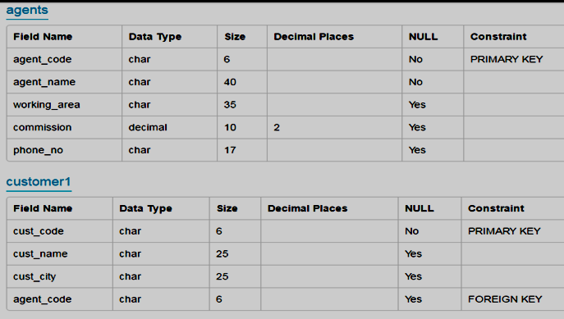

1. Fetch agent code, agent name, working area, commission, phone number of the agent table.
2. Fetch agent_code, commission fields of the agent available in agent table.
3. Modify the agent table to add the field name email.
4. Select the details of agent where commission>= 4000 and commission<=5000.
5. To remove the record from agent table whose agent name is raja.